YEAR 4 INFORMATION SHEET FOR PARENTS / CARERS
Autumn Term 2020

Class Teachers : Miss. L. Higgin, Mrs. L. John & Miss. S. Windsor
Learning Support Assistants : Mrs H. Coombes

Weekly Reminder
Monday | Tuesday | Wednesday | Thursday | Friday
Reading & spelling books | Reading & spelling books  PE Y4H  Spelling Test- Y4H | Reading & spelling books  Spelling Test- Y4J/W | Reading & spelling books | Reading & spelling books  PE Y4J/W
Our work this term will include…
- ICE COOL Topic- The Clothes Show
- Geography: map work
- History: Changes in clothes over time.
- Art: pattern work
- Music: musical elements, world dance music
- Design Technology: designing and upcycling outfits for the ICE COOL Class Clothes Show afternoon.
- Literacy: Persuasive writing, information texts & Poetry.
- Maths: Number work/shape, space, measure/data handling
- Science: ‘Forces’
- ICT: Digital literacy and Programming.
- RE: ‘Belonging and Believing’.
- Welsh: Dillad (Clothes )
- PE: Games

- Our school values this term are: Responsibility, co-operation and courage.

How you can help your child at home…
- Reading regularly, checking their understanding of the story as their AR quizzes are based on comprehension. Please encourage your child to complete AR quizzes at home. Please use this link to then complete any quizzes: https://ukhosted10.renlearn.co.uk/2238016/
- They can also read a book from home. This website can be used to check if the book is on AR and within their ZPD to do a quiz: http://www.arbookfind.co.uk
- Practise their spellings & timestables.
- Encourage independent research of our topic.
- Play numeracy and literacy games.
- Useful websites include: https://hwb.gov.wales
- https://www.doodlemaths.com
- Using timestables songs/ videos to learn their tables.

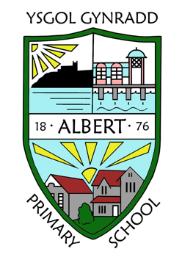
Things we need this term…

Week beginning 19/10- Bring in an old suitable clothing magazine/ catalogue.

Week beginning 9/11- Bring in a plain white T-shirt with your name clearly labelled to embellish and decorate for our DT project.

Key dates / events in our year group…

13&14/ 10 Parents’ evening.
23/10 Inset Day (School closed for pupils).
26-30/10 – Half term.
27/11 Immersion Day.
18/12 Last day of term.

Please refer to the newsletter and school website for any updates.
GENERAL INFORMATION
Please remember to inform the school office of any change of address, medication advice, home telephone number, mobile telephone number, or any other emergency contact information.

For more detailed information please refer to the School Prospectus on our website albertprimary.co.uk

