

YEAR GROUP INFORMATION SHEET FOR PARENTS

Spring Term 2022

Class Teachers: Bronwen Morgan and Sally Isaac

Learning Support Assistant: Kim Rix with Y3I



**Weekly Reminder**

|  |  |  |  |  |
| --- | --- | --- | --- | --- |
| Monday | Tuesday | Wednesday | Thursday | Friday |
| Spelling books  Reading books | Spelling books  Reading books | Spelling books  Reading books | Spelling books  Reading books | Spelling books  Reading books |
| Y3M P.E kit | Y3I P.E kit |  |  |  |

Our work this term will include…

* Literacy – Rainforest terminology; rhyming shape poetry; persuasive language; animal fact files; postcards from an explorer; virtual recount of a zoo; rhyming couplet poetry; newspaper report; explanation about Rainforest layers; instructions; Anasi the Spider story and a deforestation debate.
* Maths - Using the above multiplication tables to divide and multiply; addition 2d+2d; tens addition; subtraction 2d-2d; the 4 times table; analogue and digital time; division; multiplication; Venn and Carroll diagrams; bar and tally charts; temperature; money; measurement and fractions.
* ICT – ‘Programming’ – puppet pals; scratch coding and LegoWeDo coding.
* Ice Cool – animal puppets; Henry Rousseau art; composing Rainforest music; animal fact files; Rainforest explorers; Rainforests around the world; Anasi the Spider music; Rainforest weather and climate; Rainforest products; layers of the Rainforest; Rainforest diorama; Size of Wales virtual visit; deforestation debate and Rainforest pledge.
* Science – ‘The Human Body’ – the senses; organs, human and animal skeletons; joints; teeth; food groups and digestion.
* R.E – New year resolutions; caring for animals; Noah’s Ark; countryside code; caring for the world; St David; St Francis; Buddhism and the Easter story.
* Welsh - Our topic for this term is ‘Anifeiliaid ‘(Animals).
* Health and Wellbeing – Dance, Yoga and weekly wellbeing classroom based activities.

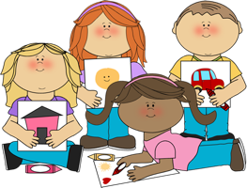

**How you can help your child at home…**

* Logging in and out of Hwb and Google Classroom (Google for Education on Hwb). Please help your child to become independent in doing this. <https://hwb.gov.wales/>
* Practising the 2, 3, 4, 5, 9 and 10 times tables (with a focus on this term’s 4 times table).
* Use doodle maths daily. <https://www.doodlelearning.com/>
* Reading regularly, checking their understanding of the story as their AR quizzes are based on comprehension. <https://ukhosted10.renlearn.co.uk/2238016/>
* Children are able to use myon as well as reading their school reading books. <https://www.myon.co.uk/index.html>
* Practicing spelling.
* Practicing cursive handwriting - the aim is that all children are using a pen by the end of Y3, however this is dependent on clear presentation and letter formation.
* All children are encouraged to research our theme of ‘The Rainforest’.



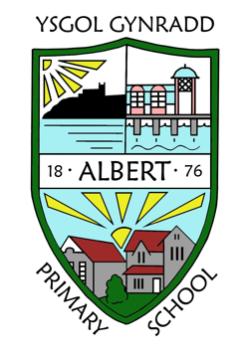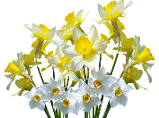

**Things we need this term…**

Please ensure that your child wears their P.E kit on their allocated day (Y3M Monday and Y3I Tuesday).

Logging in and out of Hwb and Google Classroom (Google for Education on Hwb). Please help your child to become independent in doing this.

Urdd Home Learning Art and Craft Task: We are asking pupils to create a piece of artwork as a Home Learning Task by Monday 28th February. The theme is ‘Sea to Summit’. Please see the email for more information.

Key dates / events in our year group…

February 2nd – PC Reed visit ‘- Sticks and Stones’

February 18th – INSET day

February 21st – 25th – Half Term

March 1st – St David’s day assembly

March 8th and 9th – Parents evenings

March 18th – ‘The Victorians’ Immersion day

March 23rd – The Size of Wales charity virtual visit.

April 8th – INSET day and the Easter holidays

**GENERAL INFORMATION**

|  |
| --- |
| ***Please remember to inform the school office of any change of address, medication advice, home telephone number, mobile telephone number, or any other emergency contact information.*** |

For more detailed information please refer to the School Prospectus on our website ***albertprimary.co.uk***