

YEAR GROUP INFORMATION SHEET FOR PARENTS

Autumn Term 2020

Class Teachers : Bronwen Morgan and Sally Isaac

Learning Support Assistant : Helen Coombes



**Weekly Reminder**

|  |  |  |  |  |
| --- | --- | --- | --- | --- |
| Monday | Tuesday | Wednesday | Thursday | Friday |
| Spelling books  Reading books | Spelling books  Reading books  Y3I P.E kit | Spelling books  Reading books | Spelling books  Reading books | Spelling books  Reading books  Y3M P.E kit |
|  |  |  |  |  |

Our work this term will include…

Literacy - Retelling the story of The Magic Porridge pot; animal poetry; non chronological report about animals; explanation and instructions; newspaper report on deforestation; humorous poems and poems from around the world; debate about animals in zoos and Christmas letters.

Maths - Using the above multiplication tables to divide and multiply; addition 2d+1d; tens addition; subtraction 3d-1d; the 3 times table; pictograms and tally charts; temperature; 2d shape and symmetry; compass points; capacity, weight and reading scales.

ICT - ‘Digital Literacy’ and ‘Our digital world’.

Ice Cool - ‘The Rainforest’ – creating animal maks; Henry Rousseau; researching tribes living in the Rainforest; Rainforest explorers; Rainforest climate; Bristol Zoo; layers of the Rainforest; the Size of Wales virtual workshop (including deforestation and climate change); map work; debate about animals in zoos and Rainforest music.

Science – ‘Third Rock from the sun’ – rocks, soils, materials, volcanoes, fossils and Mary Anning.

R.E - Our topic is ‘Caring for the Environment/Who’s World?’ (to include aspect of Christianity and Buddhism)

Welsh - Our topic for this term is ‘Anifeiliaid‘ (Animals).



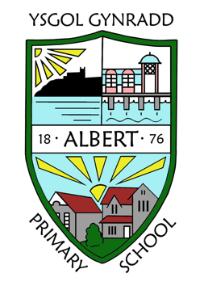



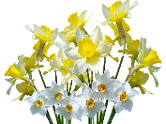

**GENERAL INFORMATION**

|  |
| --- |
| ***Please remember to inform the school office of any change of address, medication advice, home telephone number, mobile telephone number, or any other emergency contact information.*** |

For more detailed information please refer to the School Prospectus on our website ***albertprimary.co.uk***

**How you can help your child at home…**

Logging in and out of Hwb and Google Classroom (Google for Education on Hwb). Please help your child to become independent in doing this.

Practising the 2, 3, 5, 9 and 10 times tables (with a focus on this term’s 3 times table).

Reading regularly, checking their understanding of the story as their AR quizzes are based on comprehension.

Practicing spelling.

Practicing handwriting - the aim is that all children are using a pen by the end of Y3, however this is dependent on clear presentation and letter formation.

All children are encouraged to research our theme of ‘The Rainforest’.

**Things we need this term…**

Please ensure that your child wears their P.E kit on their allocated day (Y3M Friday and Y3I Tuesday). Due to the fact that lessons are outside, the children will need navy or black jogging bottoms as part of their kit.

Logging in and out of Hwb and Google Classroom (Google for Education on Hwb). Please help your child to become independent in doing this.

Key dates / events in our year group…

23rd October – INSET day

11th November – Flu spray

25th November – Size of Wales Virtual Workshop

27th November – Immersion Day