
RECEPTION INFORMATION SHEET FOR PARENTS
AUTUMN TERM 2021

Class Teachers :
Mrs M Lewis and Mrs L Morse (Mon- Thurs)/ Mrs T Hawkins (Fri)
Learning Support Assistants : Mrs C Bousie, Mr G Williams



Weekly Reminder
Monday | Tuesday | Wednesday | Thursday | Friday
Reading books and sound/high frequency word books returned to school. |  | Reading books and sound/high frequency words sent home in green bags.
Weekly snack money to be sent in £1.50. |  | P.E Lessons  Children to come to school in their P.E kit.
Our topics this term will be ‘Riddles and Rhymes’ and ‘Dragons, Unicorns and Elves’.
In Literacy we will be learning- Sound recognition, letter formation, identifying initial sounds in words, building simple cvc words such as cat, hat, pig. We will be reciting different rhymes and riddles and using actions to help us learn them.
In Maths we will be learning – Counting to 10, 20 and 100; Recognisig numbers to 5, 10 then 20; writing numbers to 5, 10 then 20; recognising simple 2d and 3d shapes; creating repeating patterns using colours and shape.
In ICT we will be learning about - E-safety, simple programming of floor robots, correct use of i-pads and equipment.
Through our topic we will be learning about different Riddles and Rhymes including traditional nursery rhymes and reciting them to our friends; we will be ordering different times of the day and finding out about different shades of colours and investigating what makes a healthy lunchbox. We will also be learning about nocturnal animals, light and dark and different light sources. We will be finding out about and celebrating different festivals throughout the Autumn Term.

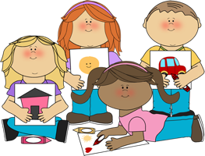

Reading and writing the sound of the day.
Reading high frequency words that they bring home.
Name writing and recognising their own name.
Sharing their reading books when they are sent home on a weekly basis.
Reading and writing numbers to 5, 10 then 20 and beyond.
Counting objects to 5, 10 then 20 and beyond.
Dressing and undressing themselves including doing up their coat.
Encourage your child to take their shoes off and put them on independently.

How you can help your child at home…





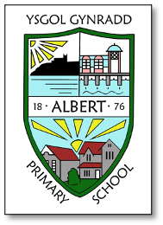
Things we need this term:
Reinforcement of sounds and numbers learnt at school through exploration in the local environment eg shape hunt, looking at shop signs and house numbers around the local area.
Discussion about healthy eating and keeping fit.
An outfit to wear for our ‘Dragons, Unicorns and Elves’ immersion Day.
Every item of personal belonging to be clearly labelled with child’s name.
Key dates / events in our year group…
13.10.21 – Individual Photographs
22.10.21 – Inset Day
25.10.21 – Half Term
02.11.21 – Immersion Day for ‘Dragons, Unicorns and Elves.’
02.12.21 – Flu Vaccinations
17.12.21 – Break Up for Christmas

GENERAL INFORMATION
Please remember to inform the school office of any change of address, medication advice, home telephone number, mobile telephone number, or any other emergency contact information.

For more detailed information please refer to the School Prospectus on our website albertprimary.co.uk

