CLASS 6 INFORMATION SHEET FOR PARENTS
SPRING TERM 2022

Class Teachers : Mrs Haldenby and Mr Thomas
Learning Support Assistants : Mrs Cross

Weekly Reminder
Monday | Tuesday | Wednesday | Thursday | Friday
CLIC Ipad | Mrs Haldenby/ Mr Thomas  Spelling  Beat That |  | Mrs Haldenby PE  Mr Thomas PE | Mrs Haldenby CLIC/SAFE  Mr Thomas  CLIC/SAFE
Our work this term will include…
Citizens of the World
- Wales – what do we know about the country we live in? Human and physical geographical features
- Who is a Global Citizen
- Diversity Matters
- Beat the flood – STEM project. Each challenge looks at problems faced by communities in the developing world, and asks the children to develop a model of their own solutions.
- Investigating properties of materials (strength and absorbency)
- Budgets/spreadsheets
- Welsh Landscapes – drawing/painting
- Climate & climate change
- Religious differences / cultural differences / traditions
- Dance
- Food from around the world
- Global issues in the environment / COP26
- Fairtrade
- Little People Big Dreams - Rosa Parks/ Martin Luther King Jr/ Floella Benjamin/ Jane Goodhall /Amelia Earhart/ Greta Thunberg/ Betty Campbell/ Emmeline Pankhurst
- Albert’s Got Talent
Exploring this topic with your child at home will support their learning in school.

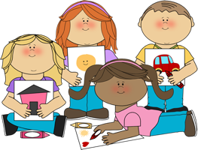
How you can help your child at home…
Reading regularly, checking their understanding of the story as their AR quizzes are based on comprehension. Please encourage your child to complete AR quizzes at home and complete the relevant part of their Reading Record. Please use this link to then complete any quizzes: https://ukhosted10.renlearn.co.uk/2238016

They can also read a book from home. This website can be used to check if the book is within their ZPD on AR to do a quiz: http://www.arbookfind.co.uk

Books can also be found on https://www.myon.com

Practising times tables. These need to be learnt at speed.
Ensure your child has their green bag in school daily. This helps with communication.
Check your child’s Home Learning Diary – your child will be set regular home learning tasks.
Your child has access to a Hwb account, on which we have our google classroom which we are encouraging them to access and complete regular home learning tasks at home.
- DoodleMaths – we are asking the children to compete 20 stars a day. This is about 10/15min activity. DoodleMaths creates every child a personalised work programme tailored to their strengths and weaknesses. DoodleMaths reinforces existing knowledge while gradually introducing new concepts, making it the perfect way to supplement school learning.

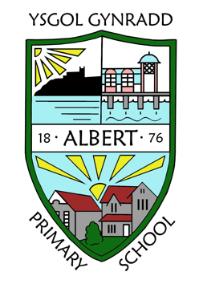
Key dates / events in our year group…
Show Racism the Red Card 10.1.22
Safer Internet Week 7.02.22
Urdd Art Competition Home Learning Spring 1 term to be submitted 28.2.22
Welsh Week 28.2.22
St Davids Day celebration 1.3.22
Parents Evenings 8.3.22 and 9.3.22
Stem week 14.3.22 (more information to follow)
Immersion Day 18.3.22
Condover Hall 28.3.22 (more information to follow)

Things we need this term…
- Reading Books and Reading Records in school every day
- Spelling books should be in school daily
- Home Learning Diaries shoud be in school daily
- Green bags daily
- If your child is to walk home on their own at the end of a school day please provide us with a letter
- Beauty and the Beast rehearsals will start later in this term after school

GENERAL INFORMATION
Please remember to inform the school office of any change of address, medication advice, home telephone number, mobile telephone number, or any other emergency contact information.

For more detailed information please refer to the School Prospectus on our website albertprimary.co.uk

