YEAR 5 INFORMATION SHEET FOR PARENTS
SPRING TERM 2022

Class Teachers: Mrs S. Osborne and Miss Fryer.
Learning Support Assistant: Mrs V Seawood & Miss F Morris.

Weekly Reminder
Monday | Tuesday | Wednesday | Thursday | Friday
Reading & spelling books | Reading & spelling books.  P.E. – Y5F (come into school in PE Kit) | Reading & spelling books  P.E. – Y5O (come into school in PE Kit) | Reading & spelling books | Reading & spelling books  Spelling Test – Y5O & Y5F  CLIC/Learn Its Tests – Y5O/F
Our work this term will include…
- Topic: Sweet Treats.
- Language, Literacy and Communication
- Story writing
- Travel writing
- Poetry
- Debating
- Script writing
- Y dref (the town)
- Mathematics and Numeracy
- Four opperations
- Fractions, decimals and percentages
- Humanities
- History of Chocolate
- Creation stories
- Health and Welling
- Dance
- Fair Trade – What is Fair Trade? The life of a coco bean farmer, Fair Trade and climate change, forest friendly farming
- Science and Technology
- Healthy Living
- Databases
- Expressive Arts
- Create package & market a new chocolate bar group task.

- Reading regularly, checking their understanding of the story as their AR quizzes are based on comprehension. Please encourage your child to complete AR quizzes at home and complete the relevant part of their Reading Record. Please use this link to then complete any quizzes: https://ukhosted10.renlearn.co.uk/2238016/
- They can also read a book from home. This website can be used to check if the book is within their ZPD on AR to do a quiz: http://www.arbookfind.co.uk
- Practise their spellings & timestables.
- Log into Doodle Maths and earn Doodle stars each day.
- Log in and familiarise yourself with your child’s Y5 Google classroom.
How you can help your child at home…

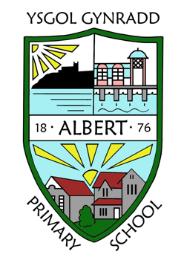
GENERAL INFORMATION
Please remember to inform the school office of any change of address, medication advice, home telephone number, mobile telephone number, or any other emergency contact information.

For more detailed information please refer to the School Prospectus on our website https://www.albertprimary.co.uk

Key dates / events in our year group…

10/02 - PC Alex Reed – Mobile Phone Talk

18/02 – INSET Day
(school closed for pupils)

21/02 – 25/02 – HALF TERM

18/03 – Immersion Day.

08/04 – INSET Day
(school closed for pupils)

07/04 – Last day of term for pupils.

Parent Consultations:
W/b 07/03/22.

Immersion Day:
18/03/22
More information to follow.

St Davids Day
01/03/22

