YEAR 5 INFORMATION SHEET FOR PARENTS
AUTUMN TERM 2020

Class Teachers: Mrs S. Osborne and Mr Williams.
Learning Support Assistant: Mrs H. Cross.

Weekly Reminder
Monday | Tuesday | Wednesday | Thursday | Friday
Reading & spelling books | Reading & spelling books.  P.E. – Y5W (come into school in PE Kit) | Reading & spelling books  P.E. – Y5O (come into school in PE Kit) | Reading & spelling books  Spelling Test – Y5O | Reading & spelling books  Spelling Test – Y5W  CLIC/Learn Its Tests – Y5W/O
Our work this term will include…
- ICE COOL Topic: Artists Impressions of the World.
DT- designing and creating a sculpture.
Geography- looking at what influences artists around the world.
Art-Research artists and draw portraits & self portraits. Looking at the links in maths and art, and music and art.
Music-Look at music from around the world and describe an emotional response to it.
- Literacy: story writing/ biographies/ observational poetry/ comic strip/ descriptive writing/ instructions and explanations and diary writing.
- Maths: number work/shape, space, measure/data handling & problem solving.
- Science: Material changes.
- ICT: Digital Literacy/ Multimedia
- RE: Believing and Doubting
- Welsh: Teledu
- PE: Dance & Games.
- Our school values this term are: Responsibility, Co-operation, Courage & Humility

- Reading regularly, checking their understanding of the story as their AR quizzes are based on comprehension. Please encourage your child to complete AR quizzes at home and complete the relevant part of their Reading Record. Please use this link to then complete any quizzes: https://ukhosted10.renlearn.co.uk/2238016/
- They can also read a book from home. This website can be used to check if the book is within their ZPD on AR to do a quiz: http://www.arbookfind.co.uk
- Practise their spellings & timestables.
- Log into Doodle Maths and earn Doodle stars each day.
- Log in and familiarise yourself with your child’s Y5 Google classroom.
How you can help your child at home…

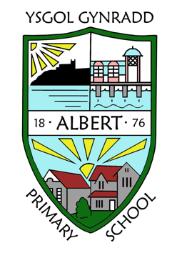
GENERAL INFORMATION
Please remember to inform the school office of any change of address, medication advice, home telephone number, mobile telephone number, or any other emergency contact information.

For more detailed information please refer to the School Prospectus on our website https://www.albertprimary.co.uk

Key dates / events in our year group…

14/10 – School photos (Indivduals)

23/10 – INSET Day
(school closed for pupils)

26/10 – 30/10 – HALF TERM

27/11 – Immersion Day.

18/12 – Last day of term.

5/1/2021 – Start of Spring Term

Parents Evening
More information to follow.

Immersion Day:
Friday 27th November
More information to follow.

